

BPEL SDL Design

Creation Date: December 9, 2013

Last Updated: June 20, 2014



The information in this document is proprietary to Neustar, Inc. It may not be used, reproduced, nor disclosed without explicit written approval.

Table Of Contents

Document History 4

Document Approvals 4

1 Document Overview 5

1.1 Introduction 5

1.2 ASSUMPTIONS 6

1.3 Related Documents 6

1.4 Issue Log 7

2 Overview 7

3 PROCESSING FLOWS 8

3.1 PREVALIDATION AND CSR REQUEST SUBMISSION 9

3.2 CSR RESPONSE PROCESSING 10

3.3 CHILD ORDER CREATION 11

3.4 LSR REQUEST SUBMISSION 12

3.5 LSR RESPONSE AGGREGRATION 13

3.6 SOA REQUEST SUBMISSION 14

3.7 SOA RESPONSE AGGREGRATION 15

3.8 FULFILLMENT PROCESSING 16

4 PREVALIDATOIN AND REQUEST PROCESSING 17

4.1 COMPONENT CHANGES 17

5 Installation Impact 48

6 Product Impact 48

6.1 ESR GUI 48

6.2 REPORTIN and BILLING 48

7 Data Model Changes 48

7.1 SEQUENCE 48

7.2 SCHEMA CHANGES –SEA SCHEMA 48

7.3 Oracle JOB/Schedule Configuration 51

7.4 STORED PROCEDURE (SEA DB) 51

8 Component Changes 52

8.1 Schema CHANGES 52

8.2 XSL transformation Templates 52

8.3 Process Director 52

8.4 JCODE CHANGES 52

9 Re-do functionality form ESR GUI 52

10 TIER 2 REFLOW SERVICES 52

10.2 ORDER stuck in PREVAL SUCCESSFUL EVENT 53

10.3 ORDER stuck in CSR_REJECTED/CSR_FAILURE event 53

10.4 order return mix onsp order 54

10.5 CHANGES to existing BPEL composite 55

10.6 ASSUMPTIONS 55

11 SCENARIOS TO BE CONSIDERED 55

11.1 Glossary of Terms 55

Document ContrOL

## Document History

|  |  |  |  |
| --- | --- | --- | --- |
| **Date** | **Version** | **Revision Description** | **Author** |
| 10/12/2013 | 1.0 | Initial version | Rajesh Vishwakarma |
| 2/1/2014 | 1.1 | Updated for java components, MLPrevalidationUtil and BpelSynchronization API | Vijay Agalcha/Ankur Shrimali |
| 21/1/2014 | 1.2 | Updated design for name changes of bpel components | Ankur Shrimali |
| 24/2/2014 | 1.3 | Updated with design for Mix ATN support | Ankur Shrimali |
| 5/14/2014 | 1.4 | Updated with SOA IVR, DL Migration and DL scheduling | Ankur Shrimali |
| 6/4/2014 | 1.5 | Updated with DL Migration design | Ankur Shrimali |

## Document Approvals

|  |  |  |
| --- | --- | --- |
| **Department** | **Representative** | **Approval Date** |
| Architecture | George Zangos |  |
| Billing Systems | Teresa Bystrek |  |
| Engineering NeuStar | Madhav Chimurkar |  |
| NeuStar QA | Jeffrey Thiel |  |
| Product Management | Anh Ngo |  |

# Document Overview

## Introduction

The purpose of this document is to describe the enhancements required to the existing Neustar BPEL automation to support Suddenlink requirements.

A custom Adapter will be built to connect to Suddenlink’s current interface. BPEL automation services will be enhanced to support SDL requirements around supporting mix order subtype and multiple ONSP/ATN orders.

BPEL 9.2 Release:

* MIX ONSP support: Support for Suddenlink PORTIN orders having multiple TNs belonging to different service providers. Order will split into multiple child orders for individual CSR and LSR transaction for different ILECs.
* MIX order subtype support: Support for Suddenlink PORTIN orders with NATIVE and PORTED TNs.

BPEL 9.3 Release:

* Multi ATN Support: Support for Suddenlink PORTIN orders where TNs belonging to one service provider will have different ATNs.
* Support for Large order handling: Automation will avoid large payload propagation through BPEL automation. Orders received from Suddenlink will be logged into ORDER_INFO table and transaction specific information will be retried before performing specific transaction.

BPEL 9.3 Release:

* ESR shall support the SOA activation at the ATN level in addition to the TN level. If a given TN of an order is provided in the IVR, ESR will activate all TNs associated with that given TN.

BPEL 9.3.5 Release:

* Log ComplexMultilineIndicator field in SEA_ESR_TRANS table.  
  Automation will populate ComplexMultilineIndicator with 'M' for master order and 'S' for child orders. This field will be 'S' for single line PORTIN orders.

BPEL 9.4 Release:

* DL Migration: support for residential to commercial and commercial to residential migration on the basis of TOS/TOA in the ESR order and the values returned in the CSR/DLI responses

BPEL 9.5 Release:

* DL Scheduling: DL will be submitted as per ILEC schedule and DDD will be adjusted as per configured no of days.
* TIER II services for SDL multiline orders.

## ASSUMPTIONS

|  |  |
| --- | --- |
|  | **Assumptions/Pre-Conditions** |
| 1 | ESR GUI will be updated to handle fallout scenarios for CSR/SOA transactions. |
| 2 | IVR activation is not part of this design document |
| 3 | Automation will submit SvCreateRequest based on the focdate of individual child order. |
| 4 | Confirmation response will be sent with farthest due date from child orders. |
| 5 | BPEL maps will be updated to bypass TXNUM generation for SDL customer. This will be taken care by automation for SDL. |
| 6 | As per new requirement automation will submit E911 request to Intrado for SDL customer. |
| 7 | In case of mix onsp order, first reject on child order will be persisted on master order and same will be sent back to adapter. |
| 8 | Automation will not persist %submitted event on master order. |
| 9 | CSR Import feature: - For multi ATN scenario, ATN will always be overridden in LSR data even if CSR import indicator is N for the combination. |

## Related Documents

|  |  |
| --- | --- |
| **#** | **Document Version and Location** |
| 1 | //custom/Suddenlink/SuddenlinkFlows v5.vsd **(CL#336667)** |
| 2 | //custom/Suddenlink/Suddenlink Requirement.doc **(CL#336687)** |
| 2 | //custom/Suddenlink/Multiple ATN LEC Use Cases.docx **(CL#336596)** |

## Issue Log

Issue log is synced in confluence <https://confluence.nexgen.neustar.biz/display/OMS/Suddenlink+IssueLog>

# Overview

Following are the main objectives of this release:

* Multiple ATNs/LECs support (BPEL 9.2 and BPEL 9.3 release)
  + Currently automation supports PORTIN orders that involve number porting from a single service Provider. SDL will send PORTIN orders where some TN may belong to different Network providers. Also the NPX-NXX information could be different for the TNs within the same provider. This requires that the SDL order will need to be segmented as follows
    - On basis of ONSP.
      * LSR: On basis of ATN
        + SOA: on basis of LRN
      * CSR: On basis of CC / CCNA information
  + Suddenlink may not send correct ATN in the initial request. Automation needs to determine the ATN based on the CSR lookup.
* Mixed order subtype support (BPEL 9.2 and BPEL 9.3 release)
  + Suddenlink can send PORTIN orders with Ported and Native TNs on a single order. Automation needs to perform Porting processing for Ported TNs and NATIVE processing for native TNs. The requirement is to hold FF processing of NATIVE TNs until PORTIN processing is complete.
  + Automation needs to determine if PORTIN TNs are pending for disconnect submission in SEA_DISCO table. All such TNs will be grouped together as order subtype RECLAIM.
* DL Migration changes (BPEL 9.4 release)
  + DL Migration support for residential to commercial and commercial to residential migration on the basis of TOS/TOA in the ESR order and the values returned in the CSR/DLI responses.

# PROCESSING FLOWS

This section describes how Suddenlink mix-ONSP/mix-ATN requests will be processed. This section also briefs about the new composites that will be created and changes to existing composites. Composite level information is also provided in component changes section.

* Automation will receive Suddenlink request from SDL adapter in SDL_ESR_ORDER_IN_QUEUE in ESR Order format.
* DequeueSDLRequest (Existing) BPEL composite will de-queue the ESR Order request from SDL_ESR_ORDER_IN_QUEUE.
* DequeueSDLRequest will invoke svcProcessMLRequest BPEL composite with SEA_Request.
* svcProcessMLRequest
  + For PORTIN order this composite will invoke svcMLPortinRequest

For non PORTIN orders, this will invoke svcProcessRequest (existing) after receiving the request from SDL adapter automation will log the received order in sea database using data layer.

Automation will perform pre-validations on individual PORTED and NATIVE Tns. The output of pre-validation will be logged into ONSP_NPA_NXX_INFO. Pre-validation process will segment the original SDL order into multiple child orders on the basis of ONSP/NPA/NXX/LRN and CCNA information.

Automation will not persist child orders until CSR processing is complete. Any failure during pre-validation/csr_failure will be persisted on the original order.

After Pre-validation and CSR processing, automation will start persisting child orders in ORDER/TRANS and HISTORY tables. From here onwards child orders will be processed individually.

Responses on individual child orders will be aggregated by Aggregation composite. After all child orders have received positive responses automation will trigger next transaction on individual child order.

## PREVALIDATION AND CSR REQUEST SUBMISSION



## CSR RESPONSE PROCESSING



## CHILD ORDER CREATION

Automation will start creating child orders after receiving CSR responses for individual orders.

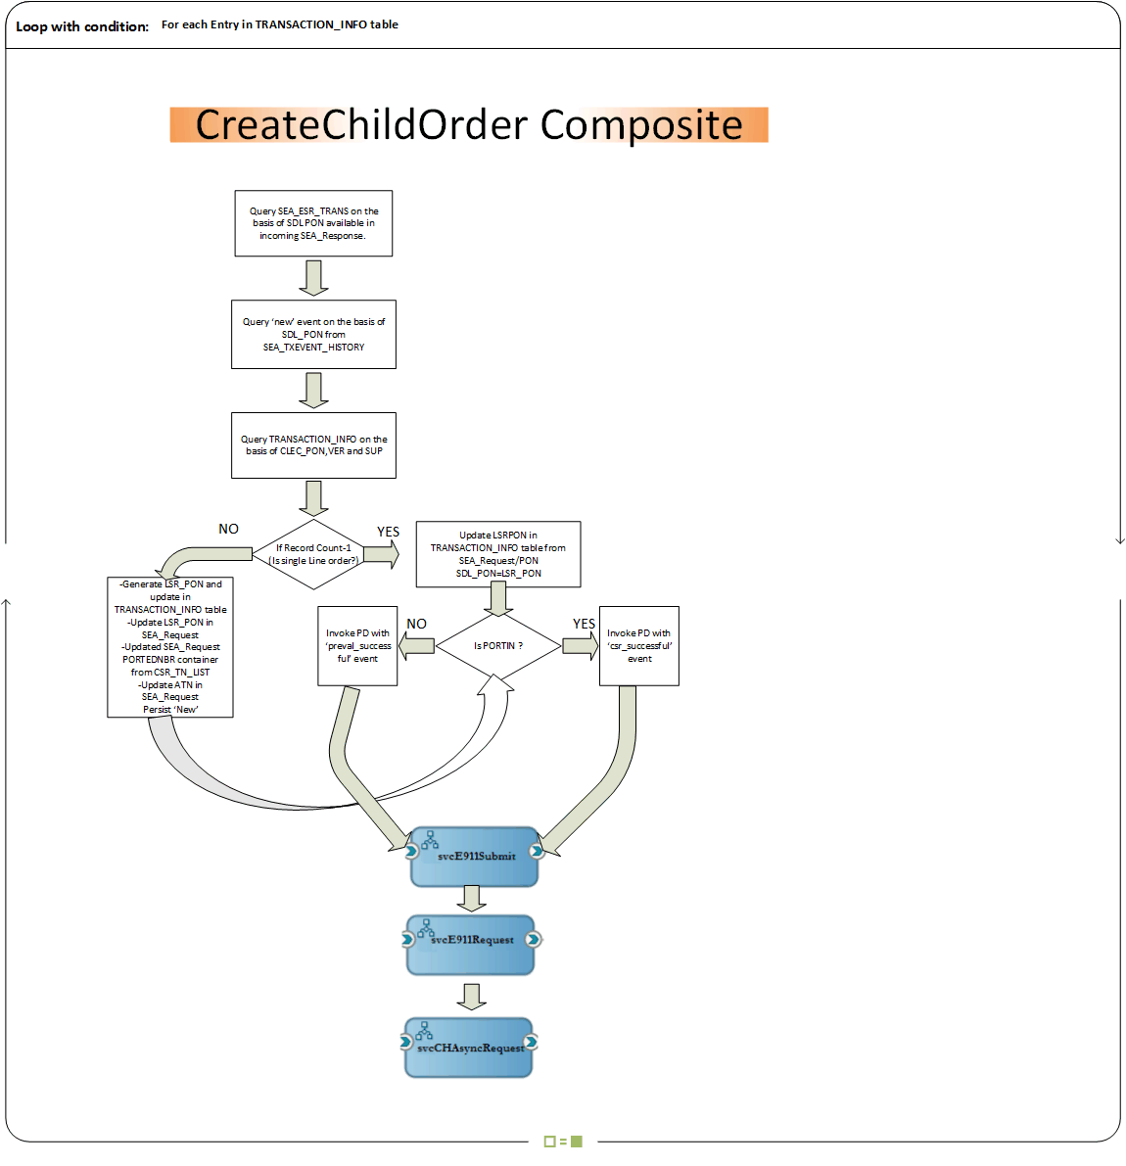

## LSR REQUEST SUBMISSION

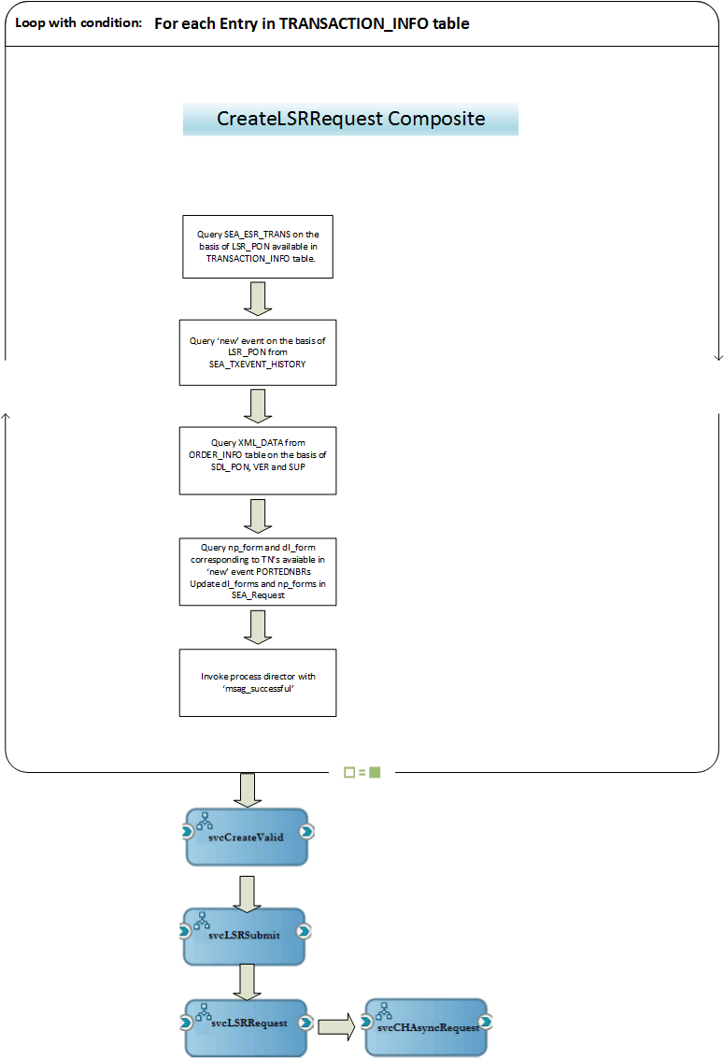

## LSR RESPONSE AGGREGRATION

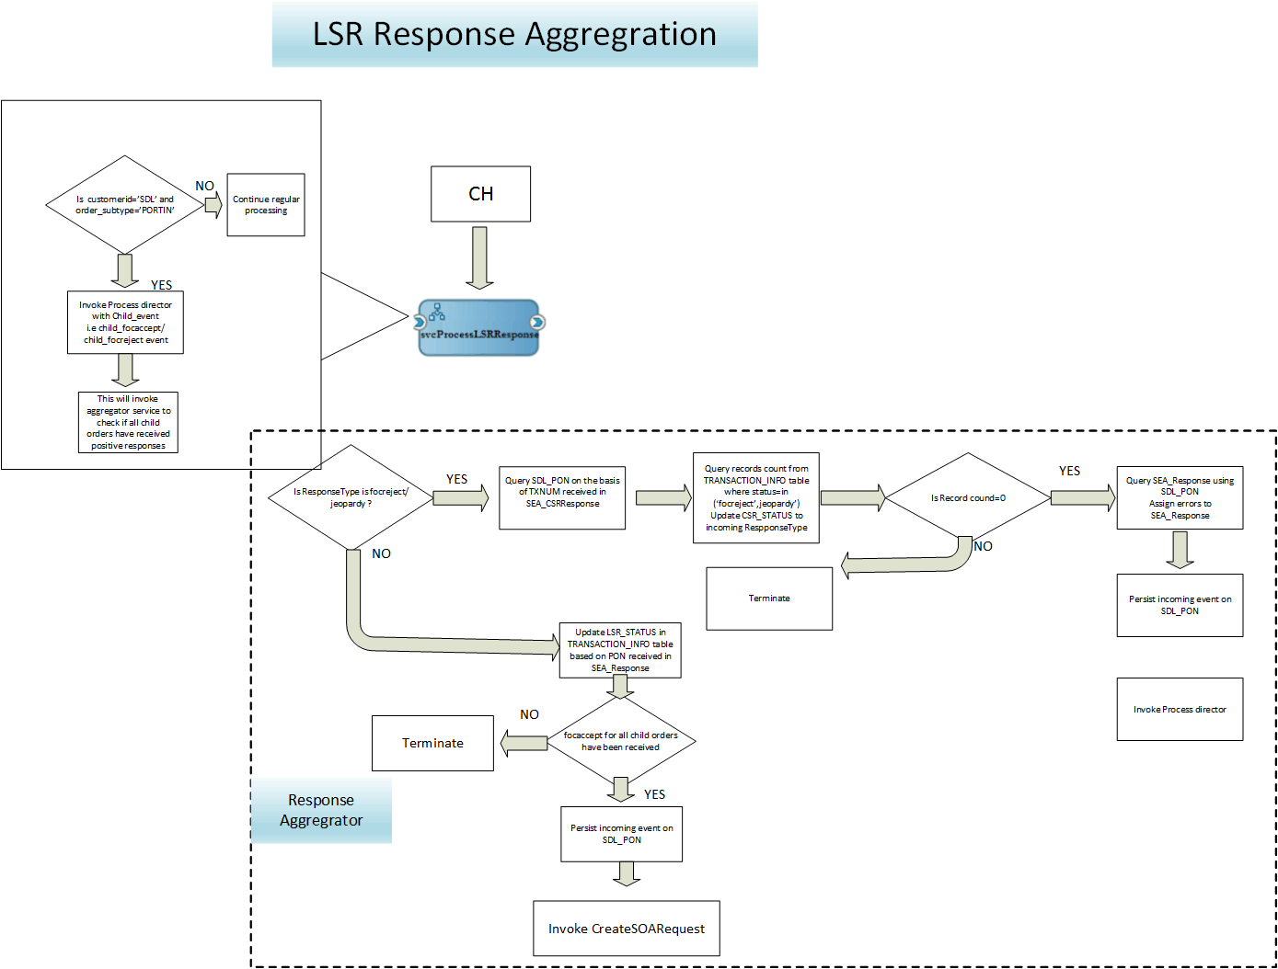

## SOA REQUEST SUBMISSION

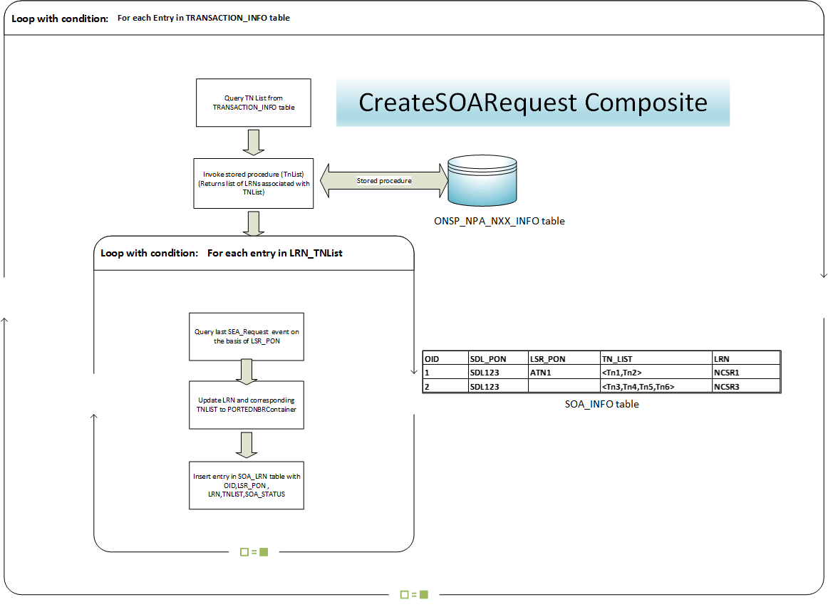

## SOA RESPONSE AGGREGRATION

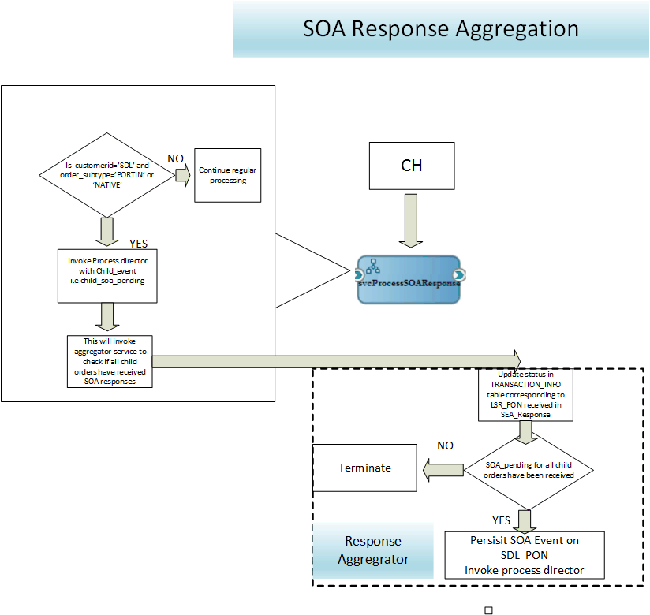

## FULFILLMENT PROCESSING

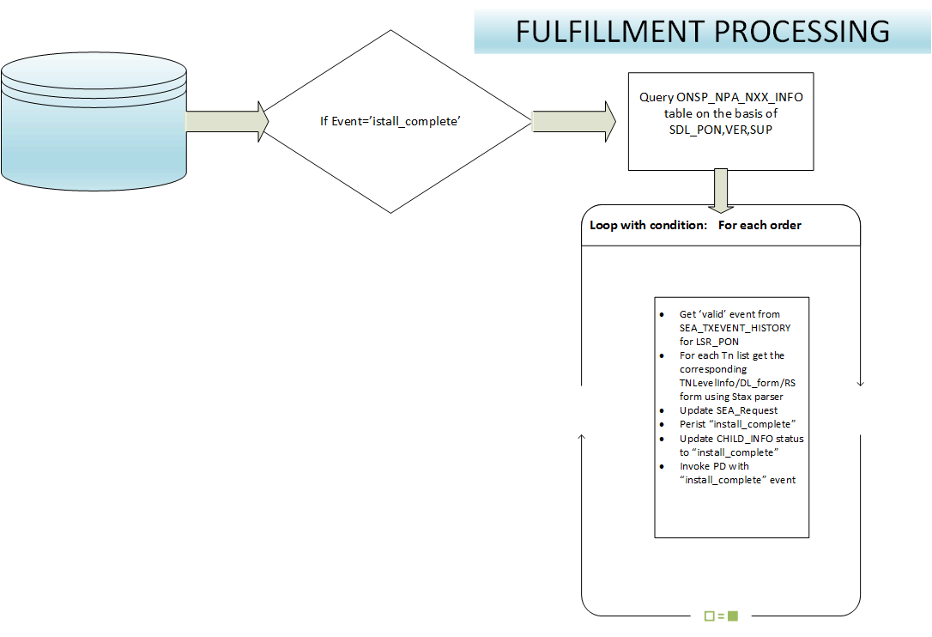

# PREVALIDATOIN AND REQUEST PROCESSING

## COMPONENT CHANGES

### MLPrevalidationUtil_ejb – Cluster (BPEL 9.2 and BPEL 9.3 release)

Overview: - This EJB application achieves pre-validation functionalities required for SDL multiline orders. Method “doPrevalidation” defined in MLPrevalUtil Bean calls the Portps service (as jaxws client) for bulk NTS lookup, followed by Spidgateway, SIV, NpaNxx, DDF and CCNA lookup. BPEL calls the EJB bean via EJB Adapter.

Details:

For all PORTIN TN list PortPS lookup is performed

* + Map<String, ONSPInfo> onspInfoMapPortin is populated
  + For each entry in onspInfoMapPortin
    - If onsp is SDL (CCNA_OWNER)
      * If TNs are in SeaDisco
        + Entry is added to onspInfoMapReclaim
        + Entry removed from onspInfoMapPortin
      * Else
        + Preval code with CCNA_OWNER returned.
    - Else
      * ONSPInfo is updated with SPID Gateway and SIV info
      * DDD check is performed.
    - For list of TN in ONSPInfo NpaNxx Lookup is performed
    - Map<String, NpaNxxInfo> npaNxxInfoMapOnsp is populated and and set in ONSPInfo.
    - For each entry in npaNxxInfoMapOnsp
      * CCNA and DDF lookup is performed and entry object updated.
* for all NATIVE tn list pps lookup is performed
  + Map<String, ONSPInfo> onspInfoMapNative is populated
  + For each entry in onspInfoMapNative
    - If onsp is not SDL (CCNA_NOTOWNER)
      * Preval code with CCNA_NOTOWNER returned.
    - For list of TN in ONSPInfo NpaNxx Lookup is performed
    - Map<String, NpaNxxInfo> npaNxxInfoMapOnsp is populated and and set in ONSPInfo.
    - For each entry in npaNxxInfoMapOnsp
      * CCNA and DDF lookup is performed and entry object updated.
* onspInfoMapPortin, onspInfoMapReclaim, onspInfoMapNative are persisted in database in “ONSP_NPA_NXX_INFO” table. “success” is returned as response indicating no preval failure.
* For SDL Green Listing Support - (BPEL 9.5.2 release)
  + If TOS=”2” and IS_GREEN_DIVISION from NPA-NXX lookup is “Y”
    - Populate DL_ILEC as “GreenBook” and by-pass DDF lookup
  + Else
    - Existing logic

### BpelSynchronization – Cluster (BPEL 9.2 and BPEL 9.3 release)

Overview: - This application registers a weblogic Singleton Service in cluster, which stores lock information in a Hashmap. This service is guaranteed to be running only one instance on only one server in the cluster. This service supports Remote Method Invocation as well. Following different API calls help in maintaining synchronization across different BPEL processing flows when invoked from BPEL services via an EJB adapter.

1. canRuninCurrentState()

Input:-LockInfo (parentOid, transOid, transaction, LockTime)

Output:-boolean

This method return Boolean true, if

1. No record exists for a combination of parentOid, transOid and transaction.
2. removeOnDone()

Input:-LockInfo (parentOid, transOid, transaction, LockTime)

Output:-int

This method removes lock from store maintained based on input passed.

If parentOid, transOid and transaction passed then lock specific for all these parameter is removed.

If only parentOid is passed then locks corresponding to all transactions are removed.

### DequeueSDLRequest – Enterprise (BPEL 9.2 and BPEL 9.3 release)

Input: GENERIC_MESSAGE_OBJECT

Type: Synchronous

Overview: This composite will route SDL PORTIN orders to ProcessMLRequest composite.

Details:

* If order subtype is PORTIN
  + Invoke a new composite ProcessMLRequest
* else
  + Invoke svcProcessRequest. (Existing behavior for non PORTIN order subtypes)

Note: Non PORTIN Orders will be processed as they are currently processed for other customers.

### ProcessMLRequest- Enterprise (**NEW**) (BPEL 9.2 and BPEL 9.3 release)

Input: SEA_Request

Type: Asynchronous

Details:

**Note: Automation does not need transaction specific data until LSR processing**.

* Log the entire xml in ORDER_INFO table with CLEC_PON,DDD, VER,SUP

Note: This xml will be used in further processing to create transaction specific data. This can be stored in zip format as well.

* Create new SEA_Request using following steps:
  + - Remove RS_Forms/np_forms/dl_forms/TNLevelInfoContainer
    - This xml will be called base xml.
* The newly created xml will have minimum information that is required up to CSR transaction. This is to avoid large xml payload propagation that could slow down BPEL processing.
* Perform CH Domain lookup on the ‘new’ SEA_Request.
* Invoke SEA_REQUEST_ENRICH map.
* If event=’new’
  + Persist “new” event (This event will have the base xml in SEA_TXEVENT_HISTORY).
  + Invoke process director with ‘new’ event. This will invoke svcSDLPreval BPEL composite.
* Else If sup in (1,2,3)
  + Invoke process director with ‘supplement’ event.

This will invoke svcProcessSuppRequest with SEA_Request

* If sup=’9’
  + Invoke process director with ‘sup3_fulfillment’

This will invoke svcProcessSupp3FFRequest (Existing) composite with SEA_Request.

### svcMLPortinPreval- Enterprise (**NEW**) (BPEL 9.2 and BPEL 9.3 release)

Input: SEA_Request

Type: Asynchronous

Overview: This composite will break SDL PORTIN order into multiple child orders based on ONSP SPID/NPA-NXX and LRN combination.

* Get PORTEDNBRCONTAINER and RSNBRCONTAINER from SEA_Request.
  + - Create a list of PORTEDNBRs and NATIVENBRs
    - Perform PortPS lookup for PORTEDNBRCONTAINER and RSNBRCONTAINER using the new PPS URL (Bulk lookup)
    - PPS service will return TN and its corresponding ONSP_SPID as a list.
      * If PPS lookup fails
        + Go to step 10: PREVA_CODE value=”PPS”
      * Else
        + continue
    - **Java call** : (SDLSPID, List Of <TN,ONSP_SPID>, “PORTIN”, List of <TN,ONSP_SPID) return by PPS for Native TNs,”NATIVE”)
      * + For “PORTIN” if any ONSP_SPID matches with SDLSPID

Return TN and String=”PREVAL_CODE value=”CCNA_OWNER”

* + - * + Else

If any ONSP_SPID doesn’t match with SDLSPID

Return TN and String=”PREVAL_CODE value=”CCNA_OWNER”

Else

Return success

* + - If output of java call No.3 is not “success”
      * Go to step 10.

Else

* + - * Continue.
    - Java call : (List Of <TN,ONSP_SPID>, “PORTIN”, List of <TN,ONSP_SPID) return by PPS for Native TNs, ”NATIVE”)
      * + Create a map ONSPSPID_TNLIST [ONSP_SPID,TNList] for PORTIN
        + Add all the NATIVE TNs with SDLSPID and TNList.

Example: < 0234, <Tn1,Tn2>

<6665, <Tn3,Tn4,Tn5>

<853C, <Tn6>

<513C, <Tn8,Tn7>

* + - * + Create a new Map ONSPINFO_TNLIST <ONSPINFO,TnList>
        + For each entry in ONSPSPID_TNLIST map

Get SPID, TnList

Create ONSP_INFO object with (ONSP_SPID,ONSP_NAME,GATEWAY,SIV,BONDED_INDICATOR,DDD_INTERVAL,SATPORT_INTERVAL)

Perform SPID_Gateway lookup for the SPID

If fails

Return PREVAL_CODE value=”SPIPD”

Update the ONSP_INFO with information received from SPID_GATEWAY lookup

Perform SIV_LOOKUP lookup for the SPID

If SIV lookup fails

Return PREVAL_CODE value=”SIV”

Update the ONSP_INFO with information received from SIV_LOOKUP lookup

Add ONSP_INFO object to ONSPINFO_TNLIST map with TNList.

Note: After we exit the above loop we would have ONSPINFO_TNLIST() map with ONSPINFO per SPID and corresponding TNList.

* + - * + Create NPA_NXX_TNLIST map
        + Create ONSPINFO_NPANXX_TNLIST map.
        + For each entry in ONSPINFO_TNLIST map[Break the TNs for NPA-NXX list]

For each TN in TNList

Query NPA_NXX_TNLIST map with the NPA_NXX of the first TN from TNList.

Entry not found.

Add an entry in NPA_NXX_TNLST map with the NPA_NXX of the TN

Add the TN to TN List.

Entry not found

Add the Tn to TN List in NPA-NXX_TNLIST map corresponding to this NPA-NXX.

After iterating the entire TNList we will have NPA_NXX_TNLIST map that will contain unique NPA-NXX and TNList.

For example: NPA_NXX_TNLIST

<111-222, <111-222-3333,111-222-5566>

<111-333, <111-333-3434,111-333-5869>

Add ONSPINFO and NPA_NXX_TNLIST to ONSPINFO_NPANXX_TNLIST map.

ONSPINFO_NPANXX_TNLIST will have <ONSPINFO, NPA-NXX_TNLIST>

* + - * + Insert the information available in ONSPINFO_NPANXX_TNLIST map to ONSP_NPA_NXX_INFO table.

Assign OrderSubtye=’NATIVE’ if ONSP_SPID is SDL SPID.

Else assign orderSubtype=’PORTIN’

|  |  |  |  |  |  |  |  |
| --- | --- | --- | --- | --- | --- | --- | --- |
| **OID** | **CLEC_PON** | **ONSP_SPID** | **GATEWAY** | **TN_LIST** | **NPA** | **NXX** | **SIV** |
| 1 | SDL1 | A | BS | <123-123-1115;123-123-2225> | 123 | 123 | LSOG6 |
| 2 | SDL1 | A | BS | <222-222-1119;222-222-2223> | 222 | 222 | LSOG6 |
| 3 | SDL1 | B | VZE | <434-434-9999;434-434-1010> | 434 | 434 | LSOG6 |
| 4 | SDL1 | B | VZE | <103-434-9999;103-434-1010> | 103 | 103 | LSOG6 |
|  |  |  |  |  |  |  |  |

Example table data with 8 TNs and 2 ONSP’s in ONSP_NPA_NXX_INFO table

* + - * + Perform DDF lookup for all unique NPA-NXX combinations available in ONSP_NPA_NXX_INFO table.
        + For each ONSP_SPID in ONSP_NPA_NXX_INFO table.

For each NPA-NXX combination [NPA-NXX lookup]

Get Tn List

Get LRN info in the form of [LRN,<TNList>]

If lookup fails

Return PREVAL_CODE value=”NPA-NXX”.

If multiple LRN found

Add existing OID to a variable “OIDToDelete”

Copy the existing row and split into as many as LRN were received also Split the TN List.

If single LRN found

Update the corresponding row with LRN value.

|  |  |  |  |  |  |  |  |  |  |
| --- | --- | --- | --- | --- | --- | --- | --- | --- | --- |
| **OID** | **CLEC_PON** | **ONSP_SPID** | **GATEWAY** | **TN_LIST** | **NPA** | **NXX** | **SIV** |  | **LRN** |
| 1 | SDL1 | A | BS | <123-123-1115> | 123 | 123 | LSOG6 | K | 56555 |
| 2 | SDL1 | A | BS | <123-123-2225> | 123 | 123 | LSOG6 | K | 56588 |
| 3 | SDL1 | A | BS | <222-222-1119;222-222-2223> | 222 | 222 | LSOG6 | L | 66666 |
| 4 | SDL1 | B | VZE | <434-434-9999;434-434-1010> | 434 | 434 | LSOG6 | M | 88888 |
| 5 | SDL1 | B | VZE | <103-434-9999;103-434-1010> | 103 | 103 | LSOG6 | N | 88888 |

ONSP_NPA_NXX_INFO table after LRN lookup

* + - End Java call 5:
      * If output=’success’
        + Continue.
      * Else
        + Go to step 10.
    - CCNA lookup:
      * For each gateway name
        + Perform CCNA lookup on the basis of CLEC, ILEC, and STATE combination.
        + If CCNA found

Update all rows for this CLEC,ILEC,STATE,SPID

Combinations

* + - * + If CCNA not found

Go to step 10.

* + - * + If duplicate records found for CLEC, ILEC and STATE combination.

For each NPA

Perform CCNA lookup for CLEC,ILEC,STATE and NPA combination

If found

Update corresponding row in ONSP_NPA_NXX_INFO table.

If not found

Go to step 9.

If multiple records found at NPA level

For each NXX

Perform CCNA lookup for CLEC,ILEC,STATE ,NPA and NXX combination

If found

Update corresponding row in ONSP_NPA_NXX_INFO table.

If not found

Go to step 9.

If multiple records found at NXX level

For each LRN

Perform CCNA lookup for CLEC,ILEC,STATE ,NPA and NXX and LRN combination

If found

Update corresponding row in ONSP_NPA_NXX_INFO table.

If not found

Go to step 9.

* + - CCNA lookup ends here

|  |  |  |  |  |  |  |  |  |  |  |  |
| --- | --- | --- | --- | --- | --- | --- | --- | --- | --- | --- | --- |
| **OID** | **CLEC_PON** | **ONSP_SPID** | **GATEWAY** | **TN_LIST** | **NPA** | **NXX** | **SIV** | **DL_ILEC** | **LRN** | **CCNA** | **CC** |
| 1 | SDL1 | A | BS | <123-123-1115> | 123 | 123 | LSOG6 | K | 56555 | BYH | ALY |
| 2 | SDL1 | A | BS | <123-123-2225> | 123 | 123 | LSOG6 | K | 56588 | BYH | ALY |
| 3 | SDL1 | A | BS | <222-222-1119; 222-222-2223> | 222 | 222 | LSOG6 | L | 66666 | TLB | BTW |
| 4 | SDL1 | B | VZE | <434-434-9999; 434-434-1010> | 434 | 434 | LSOG6 | M | 88888 | GTT | CBD |
| 5 | SDL1 | B | VZE | <103-434-9999; 103-434-1010> | 103 | 103 | LSOG6 | N | 88888 | GTT | CBD |

ONSP_NPA_NXX_INFO table after CCNA lookup

* + - Query records from ONSP_NPA_NXX_INFO table on the basis of CLEC_PON, VER and SUP.

. If record count =1

* + - * Update SEA_Request with data available in ONSP_NPA_NXX_INFO table.
      * Persist ‘perval_successfu’ event.

(This is for single line or single line/multi TN orders)

. Else

* + - * Persist preval_successful event. (This will persist preval successful on original order) new->preval_successful.

This will be a marker event on original order.

* + - * For PON, VER and SUP, query ONSP_NPA_NXX_INFO table.
      * For each CC, CCNA, GATEWAY combination.

Generate CSR_TXNUM, update CSR_TXNUM in the table.

|  |  |  |  |  |  |  |  |  |  |  |  |
| --- | --- | --- | --- | --- | --- | --- | --- | --- | --- | --- | --- |
| **CLEC_PON** | **ONSP_SPID** | **GATEWAY** | **TN_LIST** | **NPA** | **NXX** | **SIV** | **DL_ILEC** | **LRN** | **CCNA** | **CC** | **CSR_TXNUM** |
| SDL1 | A | BS | <123-123-1115> | 123 | 123 | LSOG6 | K | 56555 | BYH | ALY | NCSR1 |
| SDL1 | A | BS | <123-123-2225> | 123 | 123 | LSOG6 | K | 56588 | BYH | ALY | NCSR1 |
| SDL1 | A | BS | <222-222-1119; 222-222-2223> | 222 | 222 | LSOG6 | L | 66666 | TLB | BTW | NCSR2 |
| SDL1 | B | VZE | <434-434-9999; 434-434-1010> | 434 | 434 | LSOG6 | M | 88888 | GTT | CBD | NCSR3 |
| SDL1 | B | VZE | <103-434-9999; 103-434-1010> | 103 | 103 | LSOG6 | N | 88888 | GTT | CBD | NCSR3 |

ONSP_NPA_NXX_INFO Table

* + - * For each CSR_TXNUM in ONSP_NPA_NXX_INFO table
        + Combine TNList to create new TNList ( In example above, TN_LIST of first and second rows will be combined)
        + Insert one entry in TRANSACTION_INFO table per CSR_TXNUM
        + Initially PARENT_TXNUM will be null in TRANSACTION_INFO table.
        + Set CSR_COMPLETE flag to ‘Y’ for NATIVE and RECLAIM order subtype.

|  |  |  |  |  |  |  |  |
| --- | --- | --- | --- | --- | --- | --- | --- |
| **CLEC_PON** | **VER** | **SUP** | **CSR_TXNUM** | **PARENT_TXNUM** | **CSR_STATUS** | **CSR_TN_LIST** | **LSR_PON** |
| SDL1 | 00 |  | NCSR1 | null |  | <123-123-1115; 123-123-2225> |  |
| SDL1 | 00 |  | NCSR2 | null |  | <222-222-1119; 222-222-2223> |  |
| SDL1 | 00 |  | NCSR3 | null |  | <434-434-9999; 434-434-1010; 103-434-9999; 103-434-1010> |  |

TRANSACTION_INFO table

* + - Pre-validation failed
      * + Convert SEA_Request to SEA_Response.
        + Perform JCODE lookup.
        + Assign JCODE details.
        + Assign reject Message with TN list.
        + Persist ‘preval_failed’.
        + Invoke PD.

**Notes: Step 10** **will persist “preval_failed” on the master order and order will be returned back to SDL adapter.**

* + - Invoke PD with preval_successful event (SEA_Request) this will invoke CreateCSRRequest composite.

### GenerateCSR – Enterprise (**NEW**) (BPEL 9.2 and BPEL 9.3 release)

Input: SEA_Request

Type: Asynchronous

Overview:

* + - * If ActivityType=”RedoCSR”
  + If ONSP_NAME is in “ secondCSRIlec” dd property and csrInqIndicator is not equal to “A” in transaction info
    - Generate new TXNUM and update in ONSP_NPA_NXX_INFO and Transaction_info tables
    - Update CSR_INQ_TYPE = “A” in Transaction_Info table
    - Query CC,CCNA from ONSP_NPA_NXX_INFO table
  + Else
    - Create new record in ONSP_NPA_NXX_INFO and Transaction_Info table corresponding to input CSRTXNUM with updated TXNUM value.
    - Update new Transaction_Info record with ATN as input ATN, CSR_COMPLETE=”Y”, CSR_STATUS=”csr_successful”, MI_IND, csr_tn_list as populated from input.
    - Query CC,CCNA from ONSP_NPA_NXX_INFO table
      * Else
  + For each entry in TRANSACTION_INFO table for SDL_PON, VER and SUP and order_subtype=’PORTIN’
    - * Query CC,CCNA from ONSP_NPA_NXX_INFO table
      * Update in SEA_Request with CC, CCNA, TXNUM, BONDED_INDICATOR, ONSP_NAME etc.
      * Assign first TN from CSR_TN_LIST to PORTEDNBRContainer of SEA_Request
      * Assign first TN to ATN of SEA_Request.
      * Remove rest of the PORTEDNBRs from PORTEDNBRContainer.
      * Invoke svcCSRProcessing (Existing) BPEL service.
      * Note: This will invoke svcCSRProcessing🡪 svcCSRRequest🡪svcCHAsyncRequest.

TXNUM is already generated hence BPEL maps will be updated to bypass TXNUM generation.

After we finish the loop, CSR will be submitted for each entry in TRANSACTION_INFO table.

### svcCSRProcessing – ENTERPRISE (BPEL 9.2 and BPEL 9.3 release)

Input: SEA_Request

Type: Asynchronous

Overview:

* If ONSP_NAME is not in bonded ILEC DD property
  + - If MixONSPCustomers DVM property contains customerName
      * Update TRANSACTION_INFO table corresponding to incoming TXNUM and set CSR_COMPLETE=’YES’;
      * Invoke PD with “ml_csr_successful” event. (Existing behavior).
* Submit CSR Request as per current functionality.
  + If MixONSPCustomers DVM property contains customerName
    - Set stale check flag false.
    - Perform stale check(existing functionality)
    - If csr_response is submitted within stale hours
* For SDL set stale check true if csr_response is submitted within stale hours.
* Update csr_txnum column in TRANSACTION_INFO table with old txnum of order.
  + - Else If CSR rejected
      * Bypass persisting csr_rejected in SEA_TXEVENT_HISTORY.
      * Update CSR_XML column in TRANSACTION_INFO table corresponding to TXNUM.( This column will have reject xml for redo from GUI)
      * Invoke PD with “ml_csr_rejected”. (This will invoke ResponseAgregator service).
    - if CSR submitted
      * Bypass svcProcessCSRRequet service invocation. (Do not persist csr_submitted on child order).
    - If stale check flag is true
      * Invoke svcSDLPreval service.

### svcRouteCSRResponse –Enterprise (BPEL 9.2 and BPEL 9.3 release)

Input: SEA_CSRResponse

Type: Asynchronous

* If MixONSPCustomers DVM property contains customerName and TXNUM is present in TRANSACTION_INFO table.
  + - Update event to “ml_csr_response”.
    - Invoke svcProcessCSRResponse.

### svcProcessCSRResponse- Enterprise (BPEL 9.2 and BPEL 9.3 release)

Input: SEA_CSRResponse

Type: Asynchronous

* If event=’ml_csr_response’
  + - Get CLEC_PON from TRANSACTION_INFO table based on TXNUM.
    - Get trans record from SEA_ESR_TRANS table based on CLEC_PON and CustomerName
    - If lastResponseOID does not exist
      * Get last SEA_Request on the basis of lastRequsetOID.
      * Convert SEA_Request to SEA_Response
    - Copy CSR_Respnse data from SEA_CSRResponse to SEA_Response.
    - Perform regular CSR processing.
    - If TNMatch jcode processing returns fault (TN not match)
      * Assign csr data in SEARequest
      * Invoke GenerateCSR with activityType=”RedoCSR”
    - If MixONSPCustomers DVM property contains customerName
      * Bypass persisting the event into SEA Database.
    - Update response status (csr_successful/csr_failure) in TRANSACTION_INFO table based on TXNUM.
    - Invoke PD with ml_csr_successful/ml_csr_failure event

Note: PD call on ml_csr_successful/ml_csr_failure event will invoke a new composite MLResponseAggregator

### svcProcessCSRRequest – Enterprise (BPEL 9.2 and BPEL 9.3 release)

Input: SEA_CSRRequest

Type: Asynchronous

* If MixONSPCustomers DVM property contains customerName and order_subtype=’PORTIN’
  + Updated csr_status to csr_submitted in transaction_info table
* If MixONSPCustomers DVM property contains customerName and order_subtype=’PORTIN’
  + Prefix ml_ in event.

### svcSDLEnqueueResponse – Enterprise (BPEL 9.2 and BPEL 9.3 release)

Input: SEA_Response

Type: Asynchronous

* If MixONSPCustomers DVM property contains customerName and order_subtype=’PORTIN’
  + Updated csr_status to csr_submitted in transaction_info table
* If MixONSPCustomers DVM property contains customerName and order_subtype=’PORTIN’
  + Prefix ml_ in event.

### MLResponseAggregator: Enterprise (**NEW**) (BPEL 9.2 and BPEL 9.3 release)

Input: SEA_Response

Type: Asynchronous

Details: This composite will have following DVM properties.

**NegativeEvents:** csr_failure, order_returned, csr_rejected, lsr_rejected, jeopardy, focreject.

**PositiveEvents**:

csr_successful, focaccept, soa_pending, soa_modify_successful, soa_rel_successful, completed, cancelled

* If IncomingEvent in (‘csr_failure’,’csr_rejected’,)
  + - * Query TRANSACTION_INFO table based on TXNUM
      * Query TRANSACTION_INFO table on the basis of SDL_PON.
        + If incoming event is not present in TRANSACTION_INFO table for SDL_PON.

Update TRANSACTION_INFO table set CSR_STATUS=incomingEvent.

If SDL_PON!= SEA_Response/PON

Query SEA_Response on the basis of SDL_PON from SEA_TXEVENT_HISTORY

If found

Continue.

Not found

Query SEA_Request on the basis of SDL_PON and convert it to SEA_Response.

Update error in SEA_Response.

invoke canRunInCurrentState operation of synchronizationManager service with parent_oid, trans_oid and transaction

If return true

Persist incoming event.

Invoke process director with incoming event

Else

Continue

Else

Continue

* + - * + Else

Update TRANSACTION_INFO table set CSR_STATUS=incomingEvent.

* Else If IncomingEvent available in NegativeEvents
  + - * Query TRANSACTION_INFO table based on LSR_PON
      * Get SDL PON and Query TRANSACTION_INFO table on the basis of SDL_PON.
        + If incoming event is not present in TRANSACTION_INFO table for SDL_PON.

Update TRANSACTION_INFO table set LSR_STATUS=incomingEvent.

If SDL_PON!= SEA_Response/PON

Query SEA_Response on the basis of SDL_PON from SEA_TXEVENT_HISTORY

If found

Continue.

Not found

Query SEA_Request on the basis of SDL_PON and convert it to SEA_Response.

Update error in SEA_Response.

invoke canRunInCurrentState operation of synchronizationManager service with parent_oid, trans_oid and transaction

If return true

Persist incoming event.

Invoke process director with incoming event

Else

Continue

else

Continue.

* + - * + Else

Update TRANSACTION_INFO table set CSR_STATUS=incomingEvent.

* If IncomingEvent in (‘focaccept’,’valid’)
  + - * Query TRANSACTION_INFO table based on LSR_PON
      * Get SDL PON and Query TRANSACTION_INFO table on the basis of SDL_PON.
      * Update LSR_STATUS=incomingEvent
      * If count(*) in TRANSACTION_INFO table for the SDL_PON = count(*) for event=’focaccept’ and order_subtype=’PORTIN’ + count(*) for event=’valid’ and order_subtype=’NATIVE’

If SDL_PON!= SEA_Response/PON

Query SEA_Response on the basis of SDL_PON from SEA_TXEVENT_HISTORY

If found

Continue.

Not found

Query SEA_Request on the basis of SDL_PON and convert it to SEA_Response.

Update error in SEA_Response.

invoke canRunInCurrentState operation of synchronizationManager service with parent_oid, trans_oid and transaction

If return true

Persist incoming event.

Invoke process director with incoming event

Else

Continue

else

Continue.

* + - * Else
        + Terminate.
* Else if IncomingEvent available in positiveEvents and event is not ‘csr_successful’
  + - * Query TRANSACTION_INFO table based on LSR_PON
      * Get SDL PON and Query TRANSACTION_INFO table on the basis of SDL_PON and incomingEvent.
      * Update LSR_STATUS=IncomingEvent
      * If all rows corresponding to SDL_PON have status=incomingEvent.

If SDL_PON!= SEA_Response/PON

Update SDL_PON in SEA_Response.

Invoke synchronizationManager EJB service on canRunInCurrentState operation.

If synchronizationManager service return true

* Persist incoming event.

Else

* Continue

Else

Update SDL_PON in SEA_Response

invoke canRunInCurrentState operation of synchronizationManager service with parent_oid, trans_oid and transaction

If return true

Persist incoming event.

Invoke process director with incoming event

Else

Continue

* Else if IncomingEvent is ‘csr_successful’
  + - Query TRANSACTION_INFO table based on TXNUM received in SEA_Response.
    - If ONSP_NAME (‘ATT’,’QWEST’,’SPRINT)
      * If WTNContainer has a single TN.
        + Update the ATN received in CSR response in TRANSACTION_INFO table.
        + Generate new TXNUM and update CSR_TXNUM column in the existing record.
        + Query ‘new’ SEA_Request from SEA_TXEVENT_HISTORY.
        + Query CC,CCNA from ONSP_NPA_NXX_INFO table
        + Update in SEA_Request with CC, CCNA, TXNUM, BONDED_INDICATOR, ONSP_NAME etc.
        + Assign ATN from TRANSACTION_INFO table to ATN and First TN from TNList to PORTEDNBRContainer of SEA_Request
        + Remove rest of the PORTEDNBR from PORTEDNBRContainer.
        + Invoke svcCSRProcessing (Existing) BPEL service.

Note: This will invoke svcCSRProcessing🡪 svcCSRRequest🡪svcCHAsyncRequest and CSR for this TXNUM will be submitted.

* + - * + Terminate
      * Else
        + Continue.
    - Remove TN from TNList based on CSR response WTNContainer, assign leftover TNs to newTNList variable.
    - Update the current record with ATN, updated TnList. And status as csr_successful.
      * If newTnList is not empty
        + Copy existing record
        + Assign CSR_TXNUM to PARENT_TXNUM
        + Generate new TXNUM and assign it to CSR_TXNUM
        + Assign newTNList to CSR_TN_LIST
        + Insert the new record.
        + Query ‘new’ SEA_Request from SEA_TXEVENT_HISTORY.
        + Query CC,CCNA from ONSP_NPA_NXX_INFO table
        + Update in SEA_Request with CC, CCNA, TXNUM, BONDED_INDICATOR, ONSP_NAME etc.
        + Assign first TN from CSR_TN_LIST to PORTEDNBRContainer of SEA_Request
        + Remove rest of the PORTEDNBR from PORTEDNBRContainer.
        + Invoke svcCSRProcessing (Existing) BPEL service.
        + Note: This will invoke svcCSRProcessing🡪 svcCSRRequest🡪svcCHAsyncRequest and CSR for this TXNUM will be submitted.
      * If newTnList empty
        + Mark PARENT_TXNUM hierarchy to CSR_COMPLETE=’Y’

Back trance each record on the basis of PARENT_TXNUM until PARENT_TXNUM is found to be null.

Set CSR_COMPLETE=’Y’ for each record found.

* + - * If all entries in TRANSACTION_INFO table corresponding to CLEC_PON have CSR_COMPLETE=’Y’ {This means that the CSR activity for this SDL PON has ended we can proceed creating LSR transactions}
      * invoke canRunInCurrentState operation of synchronizationManager service with parent_oid, trans_oid and transaction
        + If return true

Persist csr_successful {This will persist csr_succesful on master record}

Invoke PD with create_child event.

This will invoke CreateChildOrder BPEL composite.

* + - * + Else

Continue

* + - * else

Terminate

### CreateChildOrders (**NEW**) (BPEL 9.2 and BPEL 9.3 release)

Input: SEA_Response

Type: Asynchronous

Details: This composite will create child orders.

If event=’csr_successful’

* + For each entry in TRANSACTION_INFO table.
    - Query SEA_ESR_TRANS on the basis of SDL PON available in incoming SEA_Response.
    - Query ‘new ’ (SEA_Request) event from SEA_TXEVENT_HISTORY (This will provide base xml)
    - Query TRANSACTION_INFO table on the basis of CLEC_PON, VER and SUP.
      * If record count=1 (Single TN or multi TN single ONSP order)

(This means that no child’s were generated and we have persisted preval_successful with validated data on SDL_PON)

* + - * + Do not generate LSR PON.
        + Update LSRPON from SEA_Request in TRANSACTION_INFO table.
        + If order_subtype=’PORTIN'

Invoke process director with csr_successful event.

* + - * + If order_subtype=’NATIVE’

Invoke process director with ‘preval_successful’ event.

* + - * + Terminate.
      * Else
        + Generate LSRPON and update in SEA_ Request.
        + Update PORTEDNBRContainer with CSR_TN_LIST from TRANSACTION_INFO table.
        + Update LSRPON in TRANSACTION_INFO table.
        + Update MML_INDICATOR to ‘S’ for this lsrpon trans
    - Update transaction specific data.
      * Query original XML_DATA from ORDER_INFO table based on SDL PON, VER and SUP indicator.
      * Query XML_DATA for data specific to validate request.
      * Update SEA_Request with information retrieved from original XML_DATA.
      * Update ATN from the transaction info table record
      * Persist ‘new’.
      * If not a single line ml order
        + Update mml_indicator to ‘M’ for clecpon trans.
      * Update SEA_ESR_TRANS table set MML_INDICATOR field as ‘S’ for each child order and ‘M’ for Master Order.
      * If order_subtype=’PORTIN’
        + Invoke process director with ‘csr_successful’ event.
      * If order_subtype=’NATIVE’
        + Invoke process director with ‘preval_successful’ event.

### svcMLReturnChildOrders (**NEW**) (BPEL 9.2 and BPEL 9.3 release)

Input: SEA_Response

Type: Asynchronous

Overview: This composite returns the master order and persist order_returned on master and it’s corresponding child orders.

* Query TRANSACTION_INFO table on the basis of CLEC_PON and VER available in incoming SEA_Response.
  + - * If record count=1 (Single TN or multi TN single ONSP order)

(This means that either no child was generated or single line order)

* + - * Get trans record from SEA_ESR_TRANS table based on CLEC_PON,VER and CustomerName.
      * If lastResponseOID does not exist
      * Get last SEA_Request on the basis of lastRequestOID.
      * Convert SEA_Request to SEA_Response
      * Copy RejectMessage, Remarks, RejectCodesContainer and Customer_Ticket_id from incoming SEA_Response to new SEA_Response.
      * Invoke PD with return_order event.This will invoke svcReturnOrder Composite.
      * Else
      * For each record get trans record from SEA_ESR_TRANS table based on its LSR_PON, VER and CustomerName.
      * If lastResponseOID does not exist
      * Get last SEA_Request on the basis of lastRequestOID.
      * Convert SEA_Request to SEA_Response
      * Copy RejectMessage, Remarks, RejectCodesContainer and Customer_Ticket_id from incoming SEA_Response to new SEA_Response.
      * For each order Persist order_returned on all child orders.
      * For CLEC_PON invoke PD with return_order event. This will invoke svcReturnOrder.

### svcCreateValid – Enterprise (BPEL 9.2 and BPEL 9.3 release)

Input: SEA_Request

Type: Asynchronous

Details: This composite will create valid on individual child orders.

* + This composite receives SEA_Request.
  + If MixONSPCustomers DVM property contains customerName and order_subtype=’PORTIN’
    - Query CSR_Response xml from SEA_PRE_LSR_TRANS (This is for CSR import functionality)
  + If MixONSPCustomers DVM property contains customerName and order_subtype=’NATIVE’
    - Invoke with ml_valid event. This will invoke MLResponseAgregrator composite.

### svcProcessLSRResponse – Enterprise (BPEL 9.4 release)

Input: SEA_Response

Type: Asynchronous

Details:

* if DL success response and SupplierName not ‘CCST’
  + If DLIlec = ‘ATTSE’
    - continue
  + else
    - get DL_MIGRATION_CONFIG corresponding to customername, suppliername, ordertype, ordersubtype
    - if dl_migration_config exist
      * if first dl submission for trans
        + get dl_submitted event
        + if DL_MIGRATION_INDICATOR is D in dl_submitted

persist response and invoke dlSubmit with DL_MIGRATION_INDICATOR as ‘N’

done.

* + - * + Else

Continue.

* + - * Else
        + continue.
  + else
    - continue
* populate lsr_adminsection PON from sequence and DL_MIGRATION_INDICATOR
* invoke updateDDD and populate DDD from response nextDate_noWait element.
* invoke svcLSRRequest.
* If MixONSPCustomers DVM property contains customerName
* Invoke PD with ml_event event. Where event could be focaccept,focreject,jeopardy etc.

This will call to MLResposeAggregator service.

### svcSOASubmit –Enterprise (BPEL 9.3 release)

Input: SEA_Request

Type: Asynchronous

Details: Service updated to assing accountID and accountName in SvCreateRequest for Mix Onsp Customer.

* + If MixONSPCustomers and SvCreateRequest
    - Get TransactionInfo for pon and ver
    - Get OrderInfo for clecPon, ver
    - Assign OrderInfo ATN field to SvCreateRequest’s accountName field and 999-<SOA_ACCOUNTID_SEQ.nextval()> to SvCreateRequest’s accountID

### svcProcessSOAResponse –Enterprise (BPEL 9.2 and BPEL 9.3 release)

Input: SEA_Response

Type: Asynchronous

Details:

* + If MixONSPCustomers DVM property contains customerName
    - Invoke PD with ml_event event. Where event could be soa_pending,soa_modify_successful etc.

This will call to MLResposeAggregator service.

### ANInstallCompleteRequest - Enterprise (BPEL 9.2 and BPEL 9.3 release)

Input: SEA_Request

Type: Asynchronous

Details:

This service will be invoked from dequeueSDLRequest with SEA_Request

* + If MixONSPCustomers DVM property contains customerName
    - Query child order from TRANSACTION_INFO on the basis of SDL PON,VER,CustomerID.
    - For each child order
      * Get ‘valid’ or ‘fulfillment_submitted’ from SEA_TXEVENT_HISTORY
      * For each PORTEDNBRContainer in SEA_Request
        + Get TNLevelInfoContainer/dl_forms/RS_Forms and update in SEA_Request
      * Persist install_complete and invoke process director.

Fulfillment will be triggered here.

* + - Persist fulfillment_submitted on parent order.

### svcOrderComplete – Enterprise (BPEL 9.2 and BPEL 9.3 release)

Input: SEA_Request

Type: Asynchronous

Details:

* + If MixONSPCustomers DVM property contains customerName and order_subtype=’PORTIN’ or ‘NATIVE’
    - Invoke process director with ml_completed event. (This will invoke MLResponseAgregator service)

### svcCancelOrder – Enterprise (BPEL 9.2 and BPEL 9.3 release)

Input: SEA_Request

Type: Asynchronous

Details:

* + If MixONSPCustomers DVM property contains customerName and order_subtype=’PORTIN’ or ‘NATIVE’
    - Invoke process director with ml_cancelled event. (This will invoke MLResponseAgregator service)

### PurgeMLTransRecord – Enterprise (New) (BPEL 9.2 and BPEL 9.3 release)

Input: SEA_Response

Type: Asynchronous

Details: This composite will be invoked on cancelled, completed event for PORTIN order subtype.

* + - Delete data from ONSP_NPA_NXX_INFO/TRANSACTION_INFO/SOA_INFO table on the basis of SEA_Resposne/PON.
    - Invoke removeOnDone operation of the BpelSynchronization service. This will remove all locks from store corresponding to parent_oid.

### svcDLIProcessing – Enterprise (BPEL 9.4 release)

Input: SEA_Request

Type: Asynchronous

Details: Composite updated to submit DLI if configured in DL_MIGRATION_FONFIG Table except for CCST.

* If DL_MIGRATION_CONFIG record found corresponding to customerName, supplierName, orderType, orderSubType
  + Submit DLI request
* Else
  + Invoke PD with dli_successful.

### svcProcessDLIResponse – Enterprise (BPEL 9.4 release)

Input: SEA_DLIResponse

Type: Asynchronous

Details: This composite will be invoked on DLI response.

* If DLI Success Response and SupplierName=’CCST’
  + Existing processing
* Else
  + Invoke PD with response event.

### svcProcessPendingTransaction – Enterprise (BPEL 9.4 release)

Input: string

Type: Asynchronous

Details: Composite updated to process pending LIDB and DL transactions.

* If varTransactionType = 'DL'
  + Assing activityType to ‘submit_dl’
  + Invoke svcDLSubmit

### svcDLSubmit – Enterprise (BPEL 9.4, 9.5 release)

Input: SEA_Request

Type: Asynchronous

Details: This composite will be invoked to submit DL.

* If DL_ILEC = '' or CustomerName='SDL'
  + Perform NpaNxx Lookup and assign DLIlec and Lex in request from NpaNxx result.

-------------------

* If ActivityType = ‘submit_DL’
  + Continue
* Else
  + updateDDD Calculation
  + if no diff in inDate and calculated nextDate
    - continue
  + else
    - persist DL Pending
    - insert record in SEA_TRANSACTION_HOLDING
    - throw DoneFault
* If DLIlec = ‘ATTSE’
  + continue
* else
  + get DL_MIGRATION_CONFIG corresponding to customername, suppliername, ordertype, ordersubtype
  + if dl_migration_config exist
    - if first dl submission for trans
      * get dli_successful event
      * Calculate TOS, TOA diff and update DL_MIGRATION_INDICATOR accordingly.
    - Else
      * Check for DL_MIGRATION_INDICATOR and if not exist populate from dl_pending.
  + else
    - continue
* populate lsr_adminsection PON from sequence and DL_MIGRATION_INDICATOR
* invoke updateDDD and populate DDD from response nextDate_noWait element.
* invoke svcLSRRequest.

### svcProcessSuppRequest – Enterprise (BPEL 9.2 and BPEL 9.3 release)

Input: SEA_Request

Type: Asynchronous

Details:

* + This composite receives SEA_Request.
  + This composite will perform checks on supplement request.
    - If SUP is not acceptable
      * Order return supplement to SDL.
    - Else
      * If MixONSPCustomers DVM property contains customerName and order_subtype=’PORTIN’
        + Invoke svcProcessMLSuppRequest via Process director.

### ProcessMLSupplementRequest - Enterprise (BPEL 9.2 and BPEL 9.3 release)

Input: SEA_Request

Type: Asynchronous

Details:

This service will receive SEA_Request

* + Query TRANSACTION_INFO table on the basis of CLEC_PON and VER not the incoming VER
  + If LSR_PON is null in TRANSACTION_INFO (This means that child orders were not created)
    - Invoke process director with send_<supplementType> event witih incoming SEA_Request
  + If LSR_PON is not null and SUP=1 or SUP=2
    - For each entry in TRANSACTION_INFO table.
      * Get trans record on the basis of LSR_PON
      * Get last request from SEA_TXEVENT_HISTORY
      * Update incoming VER,SUP,DDD in SEA_Request
      * Invoke PD with send_<SupplementType> event.
  + If LSR_PON is not SUP=3
    - Invoke process director with incoming SEA_Request and event=’send_supplement3’
    - For each entry in TRANSACTION_INFO table.
      * Get trans record on the basis of LSR_PON
      * Get last request from SEA_TXEVENT_HISTORY
      * Invoke svcCancelSOA bpel composite.

### svcLSRSubmit – Enterprise (BPEL 9.5.2 release)

Input: SEA_Request

Type: Asynchronous

Details: - service will be updated to remove DL from in case of GreenBook

* + if Customer name is in Mix ONSP customer (from DD Property) and DL_ILEC = “GreenBook”
    - Remove All DL Forms.
  + Else
    - ELT/LTY lookup will happen and existing flow would resume.

### svcUpdateDDD – Enterprise (BPEL 9.5 release)

Input: svcUpdateDDDProcessRequest

Type: Synchronous

Details: - This service perform Date calculation based on SEA_ILEC_CONFIG table data.

* + isDL_ilec = 'DL
    - assign DelayDLHours from SEA_ILEC_CONFIG table to initialWaitTime for Date next date calculation.
    - Perform Date calculation as existing logic.

# Installation Impact

Installation guide will capture all the steps to deploy the changes in production.

# Product Impact

## ESR GUI

Automation will not persist transaction history in ORDER/TRANS/History tables until CSR processing for all child order is complete. This is to avoid inconsistent data logging as CSR lookup may split the order into multiple orders based on ATN value.

After CSR transactions, automation will start persisting events in SEA database tables.

ESR GUI will require changes to provide re-do mechanism for CSR transactions from new database tables mentioned in database changes section.

## REPORTIN and BILLING

Reporting and billing scripts needs to be modified due to new database tables introduced for CSR transaction logging.

# Data Model Changes

## SEQUENCE

## SCHEMA CHANGES –SEA SCHEMA

### ORDER_INFO

|  |  |  |
| --- | --- | --- |
| **Column Name** | **Type** | **Remarks** |
| OID | NUMBER (38)  Primary Key |  |
| CLEC_PON | VARCHAR2 (32Byte)  Primary Key | This will hold the actual PON that Suddenlink has sent in the initial request |
| VER | VARCHAR2 (32Byte)  Primary Key | Version of the SDL request |
| SUP | VARCHAR2(5 BYTE) | SUP indicator |
| DDD | TIMESTAMP (0) | Due date requested by Suddenlink. |
| XML_DATA | CLOB | Original request xml received from adapter. |
| ATN | VARCHAR2(22) | SDL ATN received in request. |
| CREATED_DT | TIMESTAMP(6) |  |

### ONSP_NPA_NXX_INFO

|  |  |  |
| --- | --- | --- |
| **Column Name** | **Type** | **Remarks** |
| OID | NUMBER (38)  Primary Key |  |
| CLEC_PON | VARCHAR2 (32Byte)  Primary Key | This will hold the actual PON that Suddenlink has sent in the initial request |
| VER | VARCHAR2 (32Byte)  Primary Key | Version of the SDL request |
| SUP | VARCHAR2(5 BYTE) | SUP indicator |
| ONSP_SPID | VARCHAR2(5 BYTE) | . |
| GATEWAY | VARCHAR2(200 BYTE) |  |
| TN_LIST | VARCHAR2(200), |  |
| NPA | VARCHAR2(3) |  |
| NXX | VARCHAR2(3) |  |
| NPA_NXX_LRN | VARCHAR2(12 BYTE) |  |
| DL_ILEC | VARCHAR2(200) |  |
| LEX | VARCHAR2(8 BYTE), |  |
| LRN | VARCHAR2(12 BYTE) |  |
| SIV | VARCHAR2(200) |  |
| BAN | VARCHAR2(20 BYTE) |  |
| CIC | VARCHAR2(20 BYTE) |  |
| CC | CHAR(4 BYTE) |  |
| CCNA | CHAR(4 BYTE) |  |
| JB_CCNA | VARCHAR2(4 BYTE) |  |
| JB_CC | VARCHAR2(4 BYTE) |  |
| DDD_INTERVAL | NUMBER(3,0) |  |
| BONDED_INDICATOR | CHAR(1 BYTE) |  |
| SATPORT_INTERVAL | VARCHAR2(2 BYTE) |  |
| STATE | VARCHAR2(3 BYTE) |  |
| CSR_TXNUM | VARCHAR2(16 BYTE) |  |
| ORDER_SUBTYPE | VARCHAR2(32 BYTE) |  |
| CREATED_DT | TIMESTAMP(6) |  |

### TRANSACTION_INFO

|  |  |  |
| --- | --- | --- |
| **Column Name** | **Type** | **Remarks** |
| OID | NUMBER (38)  Primary Key |  |
| CLEC_PON | VARCHAR2 (32Byte)  Primary Key | This will hold the actual PON that Suddenlink has sent in the initial request |
| VER | VARCHAR2 (32Byte)  Primary Key | Version of the SDL request |
| SUP | VARCHAR2(5 BYTE) | SUP indicator |
| ATN | VARCHAR2(22 BYTE) | . |
| CSR_TXNUM | VARCHAR2(16 BYTE) |  |
| PARENT_TXNUM | VARCHAR2(16 BYTE) |  |
| CSR_STATUS | VARCHAR2(22 BYTE) |  |
| CSR_TN_LIST | VARCHAR2(200) |  |
| LSR_PON | VARCHAR2(32 BYTE) |  |
| LSR_STATUS | VARCHAR2(22 BYTE) |  |
| ORDER_STATUS | VARCHAR2(22 BYTE) |  |
| CSR_INQ_TYPE | VARCHAR2(3) |  |
| MI_IND | VARCHAR2(3) |  |
| CREATED_DT | TIMESTAMP(6) |  |

### SOA_INFO

|  |  |  |
| --- | --- | --- |
| **Column Name** | **Type** | **Remarks** |
| OID | NUMBER (38)  Primary Key |  |
| CLEC_PON | VARCHAR2 (32Byte)  Primary Key | This will hold the actual PON that Suddenlink has sent in the initial request |
| LSR_PON | VARCHAR2 (32Byte) |  |
| SOA_TN_LIST | VARCHAR2(200) |  |
| LRN | VARCHAR2(12 BYTE) | . |
| SOA_STATUS | VARCHAR2(22 BYTE) |  |
| ORDER_SUBTYPE | VARCHAR2(22 BYTE) |  |
| HISTORY_OID | NUMBER(38) |  |
| CREATED_DT | TIMESTAMP(6) |  |

### SEA_DL_MIGRATION_CONFIG

|  |  |  |
| --- | --- | --- |
| **Column Name** | **Type** | **Remarks** |
| CUSTOMER | VARCHAR2(20)  Primary Key |  |
| SUPPLIER | VARCHAR2(20)  Primary Key |  |
| ORDER_TYPE | VARCHAR2 (32) |  |
| ORDER_SUBTYPE | VARCHAR2 (32) |  |

### sea_ilec_config

|  |  |  |
| --- | --- | --- |
| **Column Name** | **Type** | **Remarks** |
| DELAY_LIDB_HOURS | NUMBER | Column added to hold delay in hours for lidb submission. |
| DELAY_DL_HOURS | NUMBER | Column added to hold delay in hours for DL submission. |

## Oracle JOB/Schedule Configuration

## STORED PROCEDURE (SEA DB)

# Component Changes

## Schema CHANGES

SEA_Request.xsd

SEA_Base.xsd

SEA_Header xsd

## XSL transformation Templates

## Process Director

## JCODE CHANGES

# Re-do functionality form ESR GUI

# TIER 2 REFLOW SERVICES

Automation will not log CSR transactions in regular transaction tables hence new reflow services will be provided to reflow such orders.

### clearSynchronizationLock (Tier2Services): Lock present in synchronization store and will not allow reflow to complete correctly (BPEL 9.2 release)

Input: parentOid, transOid, transaction

Output: true/false

Type: Synchronous

This service will remove lock from store maintained based on input passed. This should be invoked before reflow if in case reflow is not working due to lock present in the store. If parentOid, transOid and transaction passed then lock specific for all these parameter is removed.

If only parentOid is passed then locks corresponding to all transactions are removed.

## ORDER stuck in PREVAL SUCCESSFUL EVENT

Pre-condition: Suddenlink PORTIN order stuck in ‘preval_successful’ event and there is no record in TRANSACTION_INFO table corresponding to CLEC_PON and VER.

Steps to reflow:

* Invoke below new BPEL composite “GenerateTransInfo” with SEA_Request of preval_successful event.

### GenerateTransInfo (Tier2Services): Order stuck in preval_successful (BPEL 9.2 release)

Input: SEA_Request

Type: Asynchronous

Details:

* Invoke GENERATE_TRANSACTION_INFO stored procedure to generate TRANSACTION_INFO records on the basis of CLEC_PON and VER.
* Invoke GenerateCSR BPEL composite with incoming SEA_Request.

## ORDER stuck in CSR_REJECTED/CSR_FAILURE event

Pre-condition: CSR_STATUS corresponding to TXNUM in TRANSACTIO_INFO table is csr_rejected or csr_failure.

### SubmitCSRRequest (Tier2Services): Order stuck in preval_successful (BPEL 9.2 release)

Input:

clecPon:- String

customerId:-String

txNumCsvList:-Comma separated list of TXNUM String

bypassCSR:- String

Type: Asynchronous

Details:

* If bypassCSR flag = y
  + Get last request from SEA_TXEVENT_HISTORY
  + Convert SEARequest to SEAResponse
  + Updated CSR_STATUS = “csr_successful” and CSR_COMPLETE=”Y” in transaction_info table corresponding to csr_txnum in txNumCsvList.
  + Update SEAResponse txnum element with first txnum from txNumCsvList and event to “csr_successful”
  + Invoke pd with “ml_csr_successful”
* else
  + Query “preval_successful” SEA_Request from SEA_TXEVENT_HISTORY.

For Each TXNUM

* + Create new TXNUM and update in TRANSACTION_INFO and ONSP_NPA_NXX_INFO.
  + Get record corresponding to new txnum and Create CSR_Request,

Invoke svcCSRProcessing service.

## order return mix onsp order

### svcMLReturnOrder (Tier2Services): (BPEL 9.2 release)

Input:

clecPon:-String

ver:-String

customerId:-String

jCode:-String

rejectMessage:-String

remark:-String

Type: Asynchronous

Details:-

* for all child pon(lsr_pon) in transaction_info table corresponding to clecpon,ver
  + get SEAResponse for lsr_pon.
  + Updated jcode, rejectMessage, remark if provided.
  + Update event to “order_returned”
  + Persist response.
* Get SEAResponse for clecpon
* Update jcode, rejectMessage, remark if provided
* Invoke ProcessDirector with event return_order.

## CHANGES to existing BPEL composite

Following BPEL composites will be updated for reflowing events for SDL customer.

### svcProcessSEAResponse (Tier2Services): (BPEL 9.2 release)

Input: SEA_Response

Type: Asynchronous

* If MixONSPCustomers DVM property contains customerName and order_subtype=’PORTIN’
  + Persist incoming event.
  + Invoke processDirector with event in input SEA_Response prefixed with “ml_”.

## ASSUMPTIONS

|  |
| --- |
| **Assumption** |
|  |

# SCENARIOS TO BE CONSIDERED

|  |
| --- |
| Fallout handling for CSR transaction is not converted. |
| Partial SOA failures are will not be processed correctly. |

## Glossary of Terms

|  |  |  |
| --- | --- | --- |
| **Term / Phrase** | **Explanation** | |
|  | |  |

Table – Glossary of Terms